NAME:

Introduction
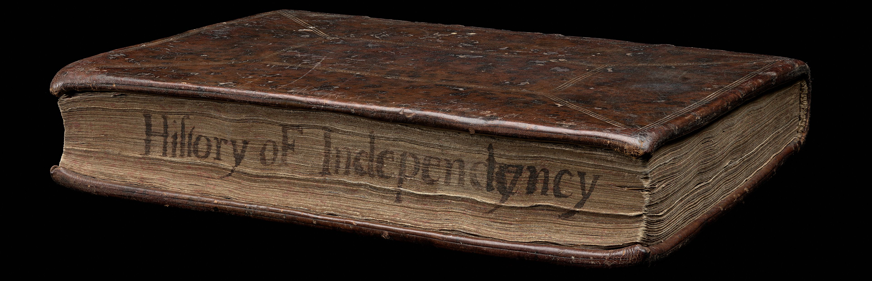

What is the Emmerson Collection?
The Emmerson Collection of rare books is an internationally significant collection of rare British printed works. It features books and pamphlets from the 15th to 18th centuries, mostly produced in England.

The collection has a particular emphasis on the reign of King Charles I and the English Civil War, fought during the 1640s. The only comparable collections belong to the British Library and Oxford’s Bodleian Library.

Its significance lies not just in the quantity and quality of the books, but also in the important provenance of items, including works originally owned by significant figures at the time of Charles I’s reign.

Watch this clip of former Principal Librarian, History of the Book and Arts, Des Cowley explain the Emmerson Collection.

Beyond the Book exhibition
The Beyond the Book exhibition was four years in the making and is a collaborative project between experts in early modern studies and the digital humanities, and specialist library staff. Beyond the Book brings the Emmerson Collection to life via an innovative digital interface that allows everyone access to the collection beyond the walls of the Library.

Curators and their exhibition
Learning intention: | We are learning to: understand the role of a curator and evaluate the effective display or exhibition of collection items and artworks.
Success criteria | I can:  - explain the role of a curator  - outline some considerations curators could make when selecting items to include in an exhibition  - evaluate the effectiveness of how items have been displayed in the Beyond the Book exhibition.

What is the role of a curator?

Read the About this Project page on the website. In what way is this exhibition a collaboration?

The digital exhibition used a technology called photogrammetry to photograph the items, creating high-definition three-dimensional representations of objects by extracting data from two-dimensional images. Watch this video explaining how the technology works.

Why do you think the curators decided to use photogrammetry technology for this exhibition?

Go to the Beyond the Book exhibition and explore the homepage, then navigate through to some of the stories. Note down three design choices the curators have made to display the items in the collection.

How effective are these design choices in helping the audience engage with the works?

Location
Learning intention: | We are learning to: understand how the location of works can influence the viewer’s understanding of the work.
Success criteria | I can:  - evaluate the benefits and limitations of displaying works in a physical or digital exhibition  - outline some ways the exhibition location influences the viewer’s understanding of the works.

The Emmerson Collection could be displayed in person, but this exhibition is a digital-only exhibition. Why do you think the curators decided to make this a virtual exhibition?

There are over 5000 items in the Emmerson Collection, but only a handful were selected for this exhibition. If you were a curator, what would you consider when deciding which items to include and which to leave out of your exhibition?

Outline the benefits and limitations of displaying works in a physical or virtual exhibition:
 | Physical exhibition | Virtual exhibition
Benefits
Limitations

Outline two ways the location of an exhibition may influence the viewer’s understanding of the work.

Expressing ideas
Learning intention: | We are learning to: understand how works demonstrate the interaction between artist and audience.
Success criteria | I can:  - analyse how one item from the exhibition was presented to engage audiences.

The works in the Beyond the Book exhibition were designed for audiences hundreds of years ago. Their stories and messages, however, still engage audiences today. The curators identified the following groups as audiences who the exhibition might appeal to:
​
- The international library sector: library professionals, academics, historians with an interest in the Emmerson Collection and rare books​
- People who love the book as an object, people interested in the history of the book​
- People with an interest in the history of the monarchy, republican movements, Charles I and the regicide​
- Teachers and high school students of History, Media, Politics, English, Literature or Visual Arts
- Collectors​
- People with an interest in craft and textiles and their uses​
- People who like beautiful old things​
- Philanthropists and donors​

Go to the Beyond the Book exhibition and select one item from the exhibition, then explain how it was presented to engage one of the audiences listed above.
Story:
Item:
Audience:
How was it presented to engage that audience?

Presentation and relationships of artworks
Learning intention: | We are learning to: explore the presentation and relationships of works in an exhibition and how the display enhances the relationship between the artist and audience.
Success criteria | I can:  - evaluate the benefits and limitations of displaying works in a physical or digital exhibition  - outline some ways the exhibition location influences the viewer’s understanding of the works.

The Beyond the Book curators chose seven stories to focus on for this exhibition:
- Making Books
- Reading Books
- Collecting Books
- Killing the King
- It’s Not Easy Being Queen
- The Prince and His Poodle
- Times of Crisis

Go to the Beyond the Book exhibition and read the descriptions for each of the stories. Why do you think these thematic areas were selected?

The following items were included in the Beyond the Book exhibition. Go to the stories and read the information about them. Then outline why you think they might have been included in the exhibition and how they might appeal to an audience.

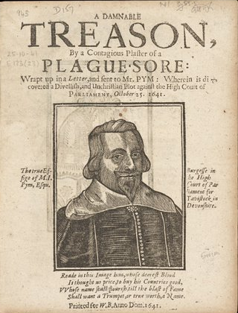  A damnable treason, by a contagious plaster of a plague-sore: wrapt up in a letter, and sent to Mr. Pym: wherein is discovered a divellish, and unchristian plot against the High Court of Parliament, October 25. 1641. 1641, printed for W.B. : London, State Library Victoria, Melbourne (RAREEMM 837/8)  Story: Time of Crisis | Why do you think this item was included?  How might this item appeal to an audience?
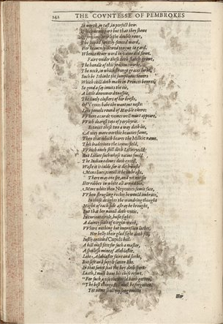  The countesse of Pembrokes Arcadia / written by Sir Philip Sidney knight. 1605, imprinted for Simon Waterson : London, State Library Victoria, Melbourne (RAREEMM 241/4)  Story: Using Books | Why do you think this item was included?  How might this item appeal to an audience?

Ethical understandings
Learning intention: | We are learning to: apply ethical understandings to a theme, concept or subject matter when making artworks
Success criteria | I can:  - apply ethical understandings to a theme, concept or subject matter when making my artworks.

The items in this collection are hundreds of years old and reflect the deeply divided opinions of people during the English Civil War. Emmerson was sympathetic to the Royalist cause, and this is seen through the choice of books and pamphlets he acquired.

Should curators be impartial when designing an exhibition?

What questions could you ask to ensure you apply an ethical understanding to a theme, concept, or subject matter when you are making your artworks?

Sponsored or donated works
Learning intention: | We are learning to: understand the role and impact of exhibiting works that have been sponsored or donated.
Success criteria | I can:  - outline the opportunities and limitations of exhibiting works that are donated or sponsored.

Watch this clip about John Emmerson as a donor.

Outline the opportunities and limitations of exhibiting works that are donated or sponsored:

Opportunities | Limitations

Develop a physical or virtual exhibition
Learning intention: | We are learning to: develop a physical or virtual exhibition
Success criteria | I can:  - brainstorm an idea for an exhibition  - outline the opportunities and limitations.

What are three observations you have noted from exploring this exhibition?

Brainstorm some ideas for your own exhibition.

Select one of your ideas and outline how your exhibition could be exhibited in a physical or virtual exhibition:

Physical exhibition | Virtual exhibition

