Activity 1: Footy Senses

Noun Adjective
Matt’s beanie with the fluffy white pom-pom squashes down his curly black hair. He’s standing in a super long line during half time. He pulls up his favourite red, blue and white socks, and then gets out of his tattered black vinyl wallet an orange twenty dollar note. He exchanges the money for his favourite snack and gets a small handful of change. He can’t wait to get back to his grey concrete seat to open up the brown paper package. He pushes the pie halfway up the bag, the blood red sauce dripping down his hand.
Suddenly -
“Oi!”
Someone bumps into him! He drops the pie.
“That was a thirteen-dollar pie!” he yells.
5 senses
Taste
Touch
Hearing
Smell
Sight






Brainstorm

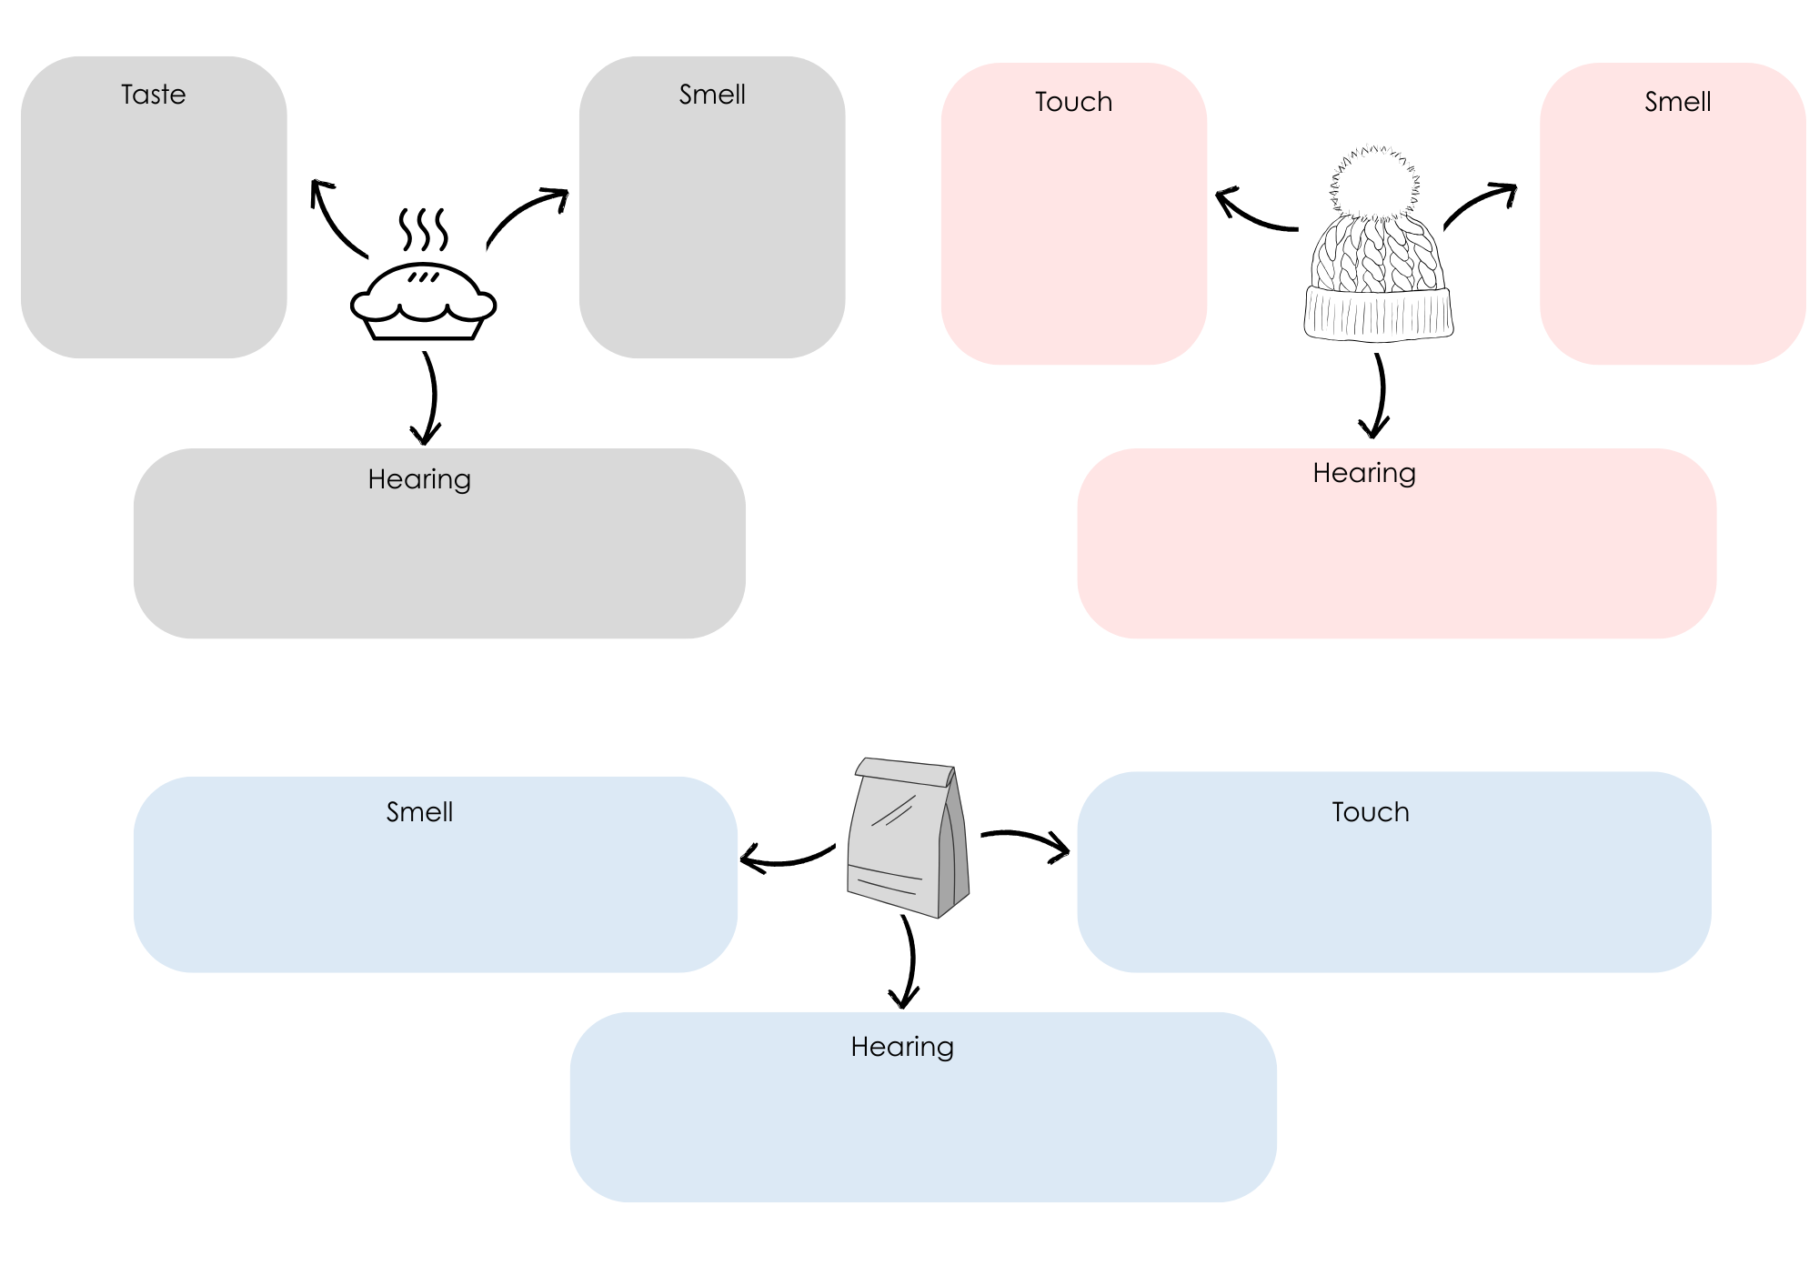
Rewrite a line from the story from the previous page to include more sensory imagery:

Activity 2: Illustrate your guernsey!
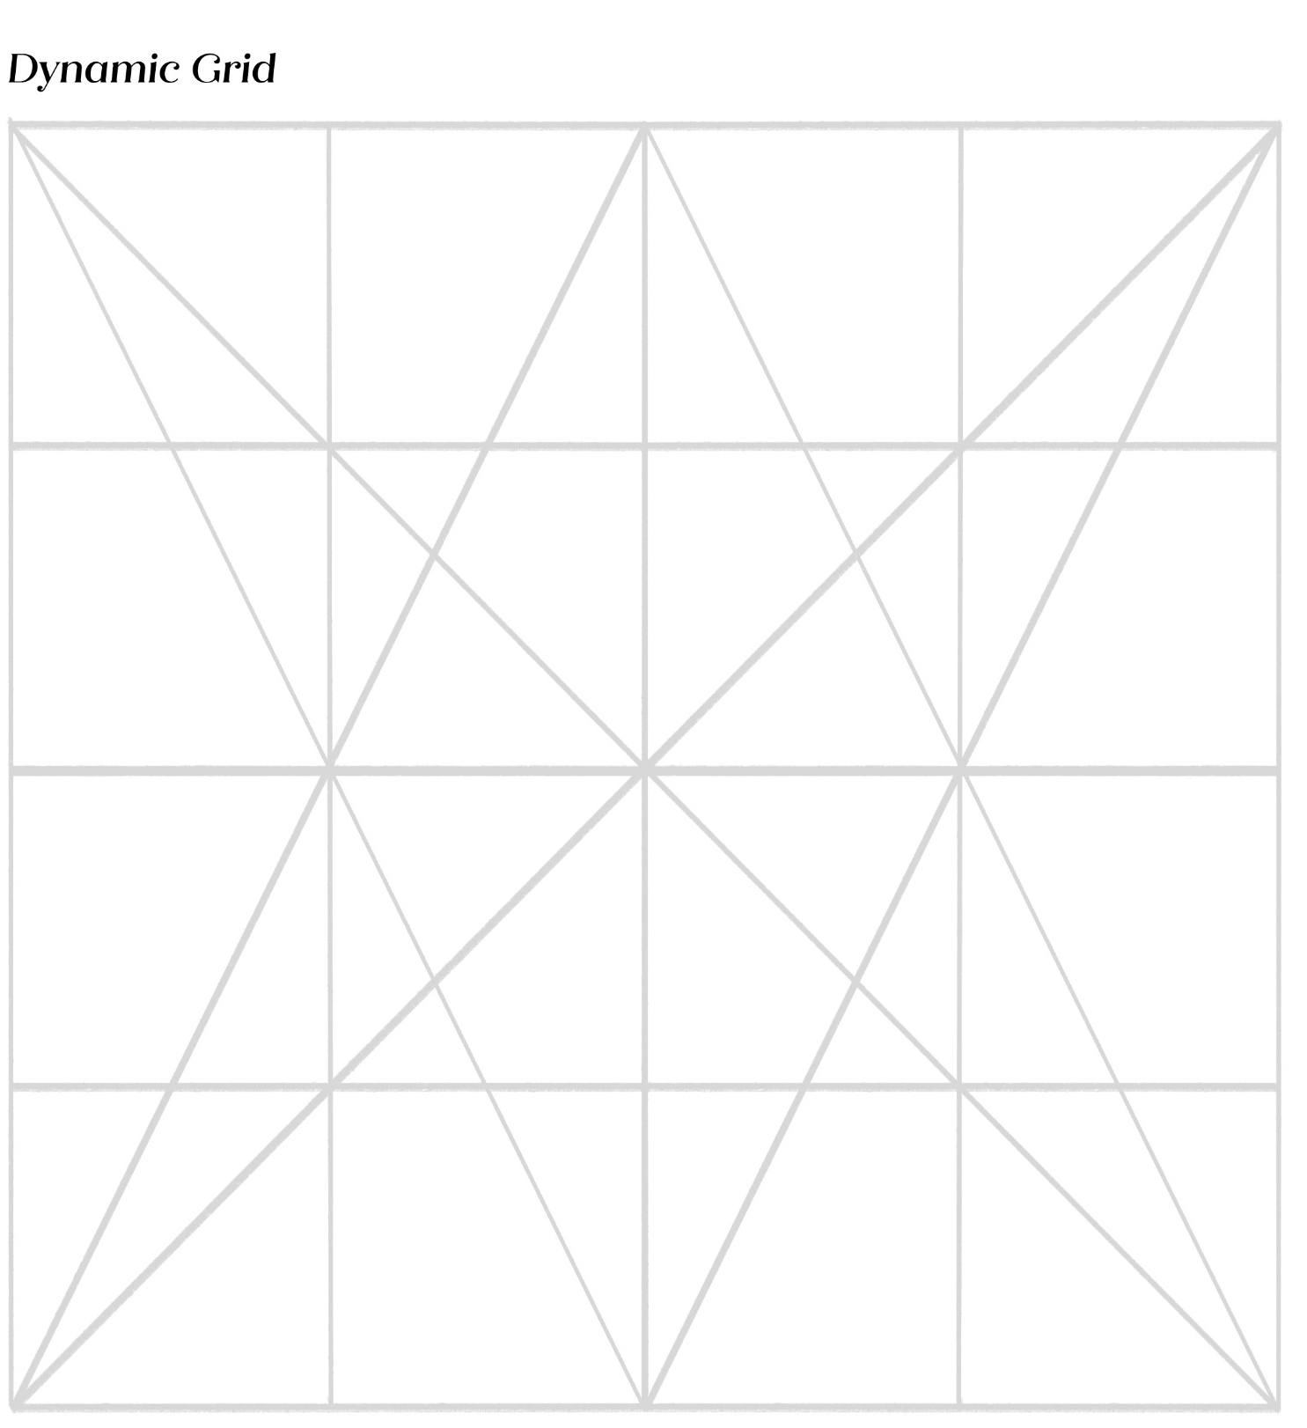
Team Name:

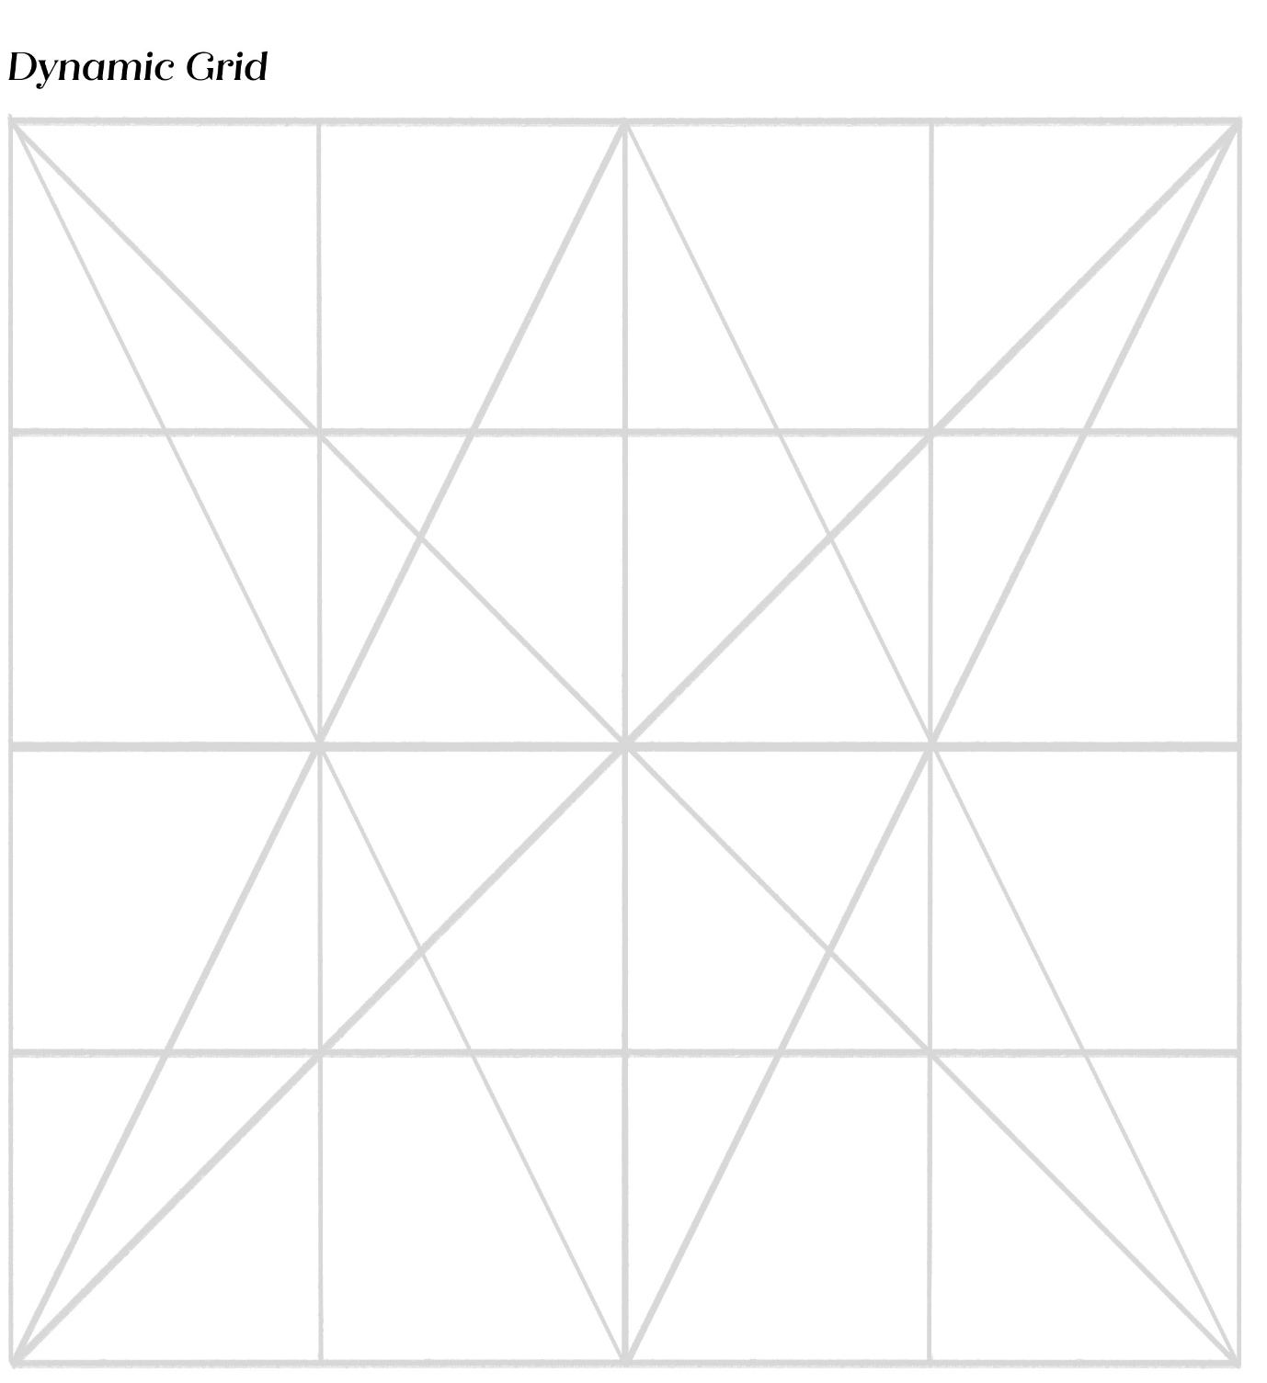

Activity 3: Show them the Footy!

Sam’s not so confident. This is her first game. She’s feeling anxious, fidgety and fearful. When the ball seems to come towards her she catches it, but she doesn’t know what to do! She knows the ball was meant for Maya, the better player, but it somehow ended up in her hands, so she handballs it to Tima and immediately regrets it, because Maya is glaring at her with anger.
Maya is frustrated and filled with rage. She can’t believe Sam didn’t give her that mark, and instead passed it to Tima, who’s not even looking.
But then like magic, Tima seems to snatch it from thin air. And she kicks a goal!
Tima’s face at first looks surprised, baffled, and then she feels giddy with new excitement, which cranks up to pure joy – she can’t believe she has done it! She has kicked the first goal!

Brainstorm
Emotion: | Facial expression/body language:

Rewrite a line from the story above to describe the emotion without naming it:

