Welcome to Make Your Mark!
During this event, your students will be asked to help author Alice Pung and illustrator Sher Rill Ng offer some top tips to AFL and AFLW football players to help improve their work.
Listed below is an outline of the three activities Alice and Sher Rill will guide the students through. We have included the instructions, so you can support your students throughout the session. We have also provided two student versions, one of which scaffolds the activities.

Activity 1: Footy Senses

Learning Intention | We are learning to: enhance the imagery of a text using sensory language (taste, sight, smell, hearing, touch)
Success Criteria | I can:  - Recall the 5 senses  - Identify parts of a text that use visual descriptions  - Replace some visual descriptions with imagery that utilises other senses

v
Resources you will need for this lesson:
- Activity 1 Writing Passage
- Writing Materials


Activity Overview:
- The following text will be sent in by a football player. Alice and Sher Rill will read it to the students and then unpack some ideas about how it could be improved by including imagery that utilises other senses such as (taste, smell, hearing, touch).

Matt’s beanie with the fluffy white pom-pom squashes down his curly black hair. He’s standing in a super long line during half time. He pulls up his favourite red, blue and white socks, and then gets out of his tattered black vinyl wallet an orange twenty dollar note. He exchanges the money for his favourite snack and gets a small handful of change. He can’t wait to get back to his grey concrete seat to open up the brown paper package. He pushes the pie halfway up the bag, the blood red sauce dripping down his hand.
Suddenly -
“Oi!”
Someone bumps into him! He drops the pie.
“That was a thirteen-dollar pie!” he yells.
Noun Adjective

- Using the activity page the students will be asked to brainstorm with Alice and Sher Rill to see if they can come up with some other ways to describe the nouns highlighted in the passage using sensory imagery other than sight.

- The students will then be invited to rewrite at least one line of the passage to include more sensory imagery.
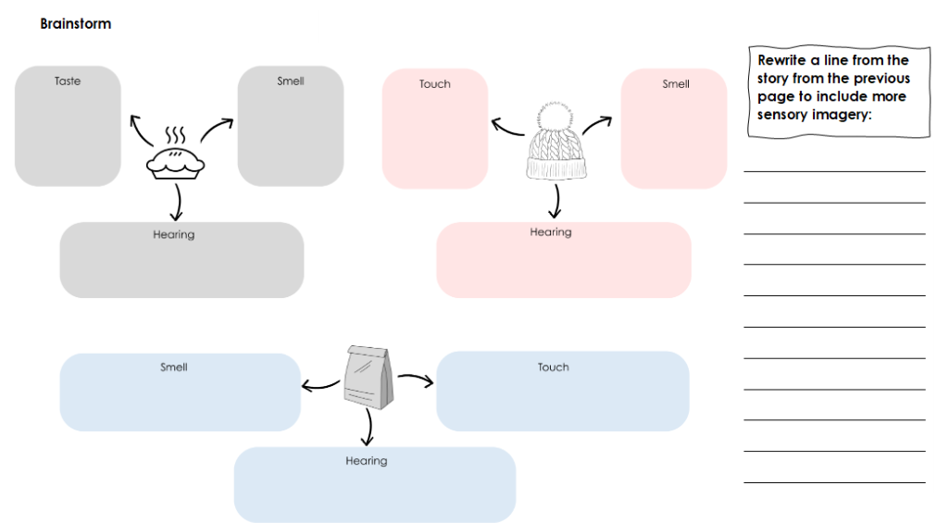

Activity 2: Illustrate your guernsey!

Learning Intention | We are learning to: draw a football guernsey using the dynamic grid method
Success Criteria | I can:  - Explain how a dynamic grid works  - Follow along with the illustrator  - Use a dynamic grid to illustrate a football guernsey  - Colour in my illustration

v
Resources you will need for this lesson:
- Activity 2 Dynamic Grid – Football Jumper
- Activity 2 Dynamic Grid – Premiership Cup
- Drawing Materials

Lesson Overview:
- Students follow along as Sher Rill demonstrates how to illustrate a football guernsey using the dynamic grid.

- Students will then be given a choice to either design their own football team guernsey and colour in the jumper they have just illustrated OR follow along as Sher Rill demonstrates a more challenging illustration of a premiership cup. The session will be recorded so you can return to the instructions at a later date if students prefer to colour in their guernseys.

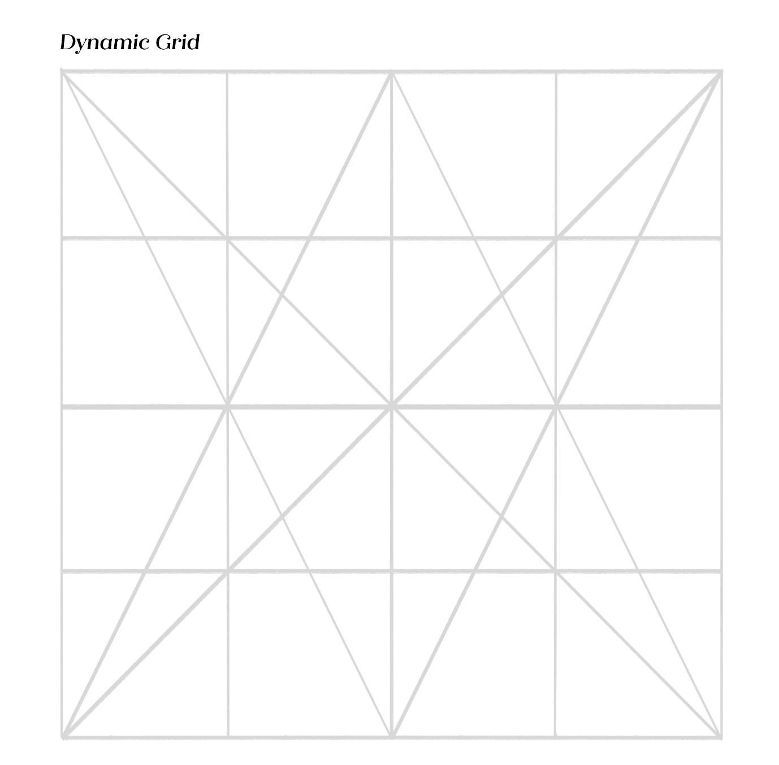
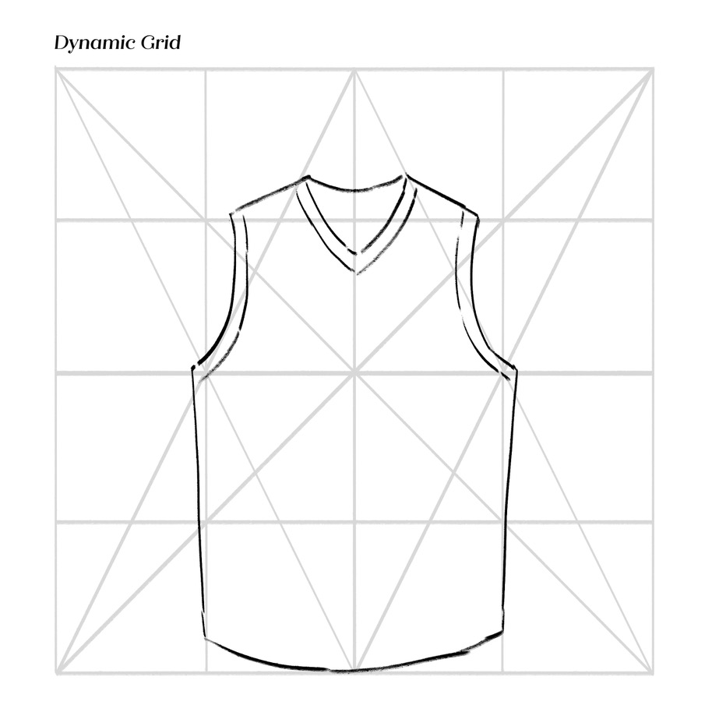
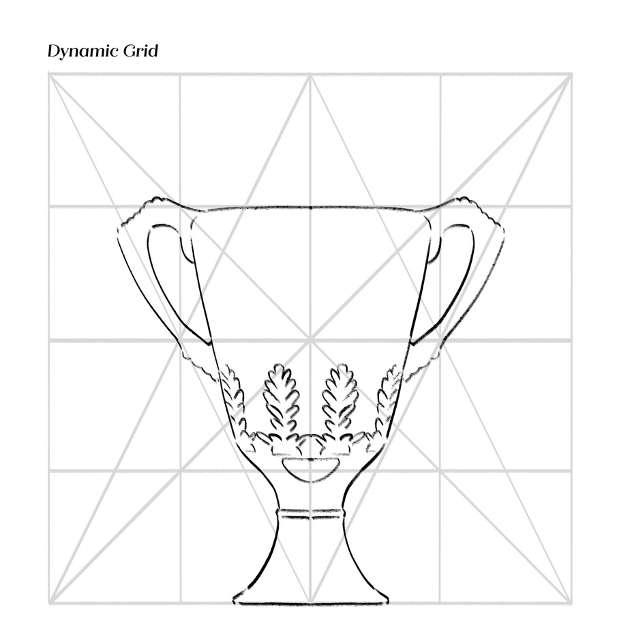

Activity 3: Show Them the Footy!

Learning Intention | We are learning to: use the show don’t tell strategy to describe emotions in a way that helps our readers feel and understand what a character is experiencing
Success Criteria | I can:  - Describe emotions through actions and reactions  - Use descriptions of body language and facial expressions

v
Resources you will need for this lesson:
- Activity 3 Writing Passage
- Writing Materials

Lesson Overview:
- Alice and Sher Rill will read the passage to the students and ask the students to help them identify all the moments where the author writes about the emotions the characters are feeling.
Sam’s not so confident. This is her first game. She’s feeling anxious, fidgety and fearful. When the ball seems to come towards her she catches it, but she doesn’t know what to do! She knows the ball was meant for Maya, the better player, but it somehow ended up in her hands, so she handballs it to Tima and immediately regrets it.
Maya is frustrated and filled with rage. She can’t believe Sam didn’t give her that mark, and instead passed it to Tima, who’s not even looking.
But then like magic, Tima seems to snatch it from thin air. And she kicks a goal!
Tima’s face at first looks surprised, baffled, and then she feels giddy with new excitement, which cranks up to pure joy – she can’t believe she has done it! She has kicked the first goal!
- Once the students have identified moments where the characters show emotions, Alice and Sher Rill will guide the students through the method of show don’t tell. They will use drawings of the characters and ask the students to describe their facial expressions and body language to describe a character’s emotion.
- The students will then have some time to rewrite at least one line in the passage to describe the character’s emotion without naming what the emotion is.

